

**School of Computer Science and Engineering**

**J Component report**

**Programme : B.Tech(CSE)**

**Course Title : Image Processing**

**Course Code : CSE-4019**

**Slot : E1**

**Title: Low-Light Image Enhancement using Image Processing Techniques**

**Team Members: Vishwanath B Bhat|19BCE1499**

**Likith M D | 19BCE1668 C R Dhruv|19BCE1476**

**Faculty:** Dr Geetha S **Sign:**

**Date:**

**Contents:**

1. **Abstract ……………………………………………………………….……….2**
2. **Introduction …………………………………………………………………...3**
3. **Motivation ………………………………………………………………….….5**
4. **Related Works …...……………………………………………………………6**
5. **Proposed Work …………………………………………………………….….8**
6. **Project Output …….…………………………………………………………11**
7. **Conclusion and Framework ………………………………………………...12**
8. **References…………………………………………………………………….12**

**Abstract:**

In this Project, we are going to implement an efficient fusion-based process for enhancement of the weakly illuminated images which takes use of several image processing techniques. Firstly, we would deploy an illumination estimating algorithm based on the morphological closing methodology for decomposing an input image into a reflectance image and an illumination image. Next, we get two inputs which represent the luminance-improved and contrast-enhanced images of the previous illuminated images using the sigmoid function and adaptive histogram equalization. Then we produce an adjusted illumination by combining the developed inputs with their corresponding weights in a multi-scale way. By using a proper weighting and fusion plan, we will merge the benefits of different techniques to develop the adjusted illumination. Finally, the enhanced image shall be obtained by compensating the already adjusted illumination back to the reflectance. By this fusion-based technique, images of weak illumination conditions like night time images and backlight images can be enhanced.

**Introduction:**

The use of a digital computer to process digital photographs through an algorithm is known as digital image processing. Digital image processing, as a subsection or field of digital signal processing, provides numerous advantages over analogue image processing. It enables a considerably broader choice of algorithms to be applied to the input data, as well as the avoidance of issues such as noise and distortion during processing.

Digital image processing may be described as multidimensional systems since images are defined in two dimensions (or more). Three aspects influence the genesis and development of digital image processing: first, the growth of computers; second, the development of mathematics (especially the creation and improvement of discrete mathematics theory); third, the need for a wide range of applications in the environment, agriculture, military, industry, and medicine has grown.

The goal of low-light image enhancement is to improve the perception or interpretability of an image acquired in a dimly illuminated situation. Deep learning-based solutions, which use a variety of learning methodologies, network architectures, loss functions, training data, and other techniques, have dominated recent breakthroughs in this field. We present a comprehensive assessment in this study that covers a wide range of topics, from algorithm taxonomy to outstanding issues. To test the generalization of existing approaches, we present a low-light image and video dataset, consisting of photos and films captured by several mobile phone cameras under varying lighting circumstances.

Furthermore, for the first time, we present a unified online platform that includes a wide range of common LLIE approaches, with results generated via a user-friendly web interface.

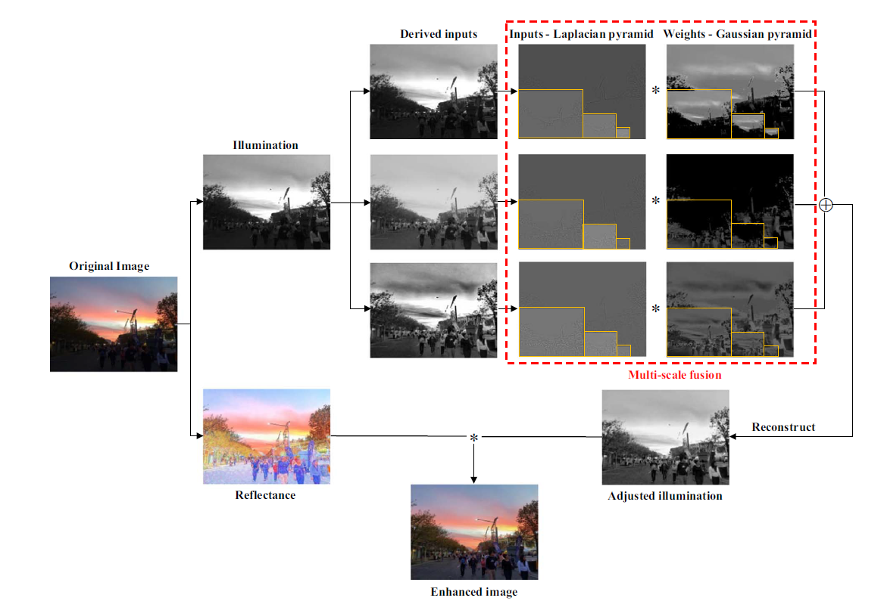

Figure: Overview of the proposed Low-light Image Enhancement method.

**Motivation:**

Because illumination is linked to the naturalness of the image and the Human Vision System is sensitive to fluctuations in brightness, adjusting illumination is a natural and straightforward technique to remedy this problem for weakly lighted images. In other words, the image's illumination affects both its objective (detail improvement) and subjective (naturalness) quality. However, parameters are difficult to set for some illumination-estimating algorithms based on Retinex theory. Other approaches, on the other hand, take a long time to compute since they involve solving a large number of linear equations or using patch-based filtering. As a result, the first and most critical duty is to accurately and efficiently estimate the illumination.

The second objective is to correctly modify the estimated lighting for photographs that are poorly lit. Image quality evaluation is well-known to be linked to the Human Vision System, which is sensitive to brightness and contrast. When global brightness is compressed to highlight dark portions in a picture, however, local contrast may be lowered. Finding a balance between brightness and contrast is thus a crucial requirement for image enhancement.

**Related Works:**

**Research Paper-1:**

**A fusion-based enhancing method for weakly illuminated images**

This paper presents a straightforward and effective fusion-based technique for rectifying photos with dim light that employs multiple well-known image processing techniques. The first part of this algorithm involves the use of a morphological closing-based illumination estimation technique to split the source picture into a reflectance image alongside an illumination image. The second step involves the simultaneous use of a sigmoid function and adaptive histogram equalization, yielding two different inputs that are having improved luminance and improved contrast variations of the original decomposed image. The paper then describes how they modify the illumination by fusing the newly generated inputs with their corresponding weights in a multi-scale manner, employing two weights depending on these inputs. The paper then details about working with and incorporating the advantages of various strategies to provide the changed lighting using a correct weighting and fusion process. By compensating the corrected image, the final improved image is obtained. By adjusting the lighting back to reflectance, the final augmented picture is created. The augmented image reflects a trade-off between detail increase, local contrast improvement, and maintaining the image's natural feel as a result of this synthesis. Images in varied weak illumination situations, such as backlighting, non-uniform illumination, and night time, can be improved using the suggested fusion-based framework.

**Research Paper-2:**

**Photographic Tone Reproduction for Digital Images**

The paper first describes an existing classic photography challenge that is, the conversion of real-world high luminance range images to the range of low dynamic range of the photographic print. The same tone reproduction issue is faced by professionals working in the field of animation and computer graphics and they must deal with the mapping of digital images to a screen or to a print of low dynamic range. Within this paper, the research reported uses tried-and-true photography approaches such as dodging and burning and luminance mapping to create a novel tone reproduction operator. Ansel Adams' approach for dealing with digital photographs is utilized in this regard. The final resultant method is elementary and has been proved to deliver decent outputs over a diverse range of photos.

**Proposed work:**

Based on the research paper [1] we decided to implement the proposed architecture in that paper. There were other alternatives but this particular model is extremely simple as well as powerful. The suggested fusion-based method works by combining numerous inputs and weights obtained from a single estimated illumination. Global brightness improvement, local contrast enhancement, and preservation of detail are the three criteria for enhancing weakly light images, as stated above. As a result, these criteria are used to create and process inputs and weights. The proposed boosting method is made up of four basic steps that correspond to the four subsections below:

* Illumination estimation
* Input derivation,
* Weight definition
* Multi-scale for input and weight fusion.

We'll go over each of these in turn.

1. **Illumination estimation**

We utilise a simplified physical model of light reflection for images that are dimly lit. A captured picture, according to Retinex theory, is the product of reflectance and illumination written as



S->Measured Image R->Reflectance I->Illumination c->Color channel of RGB

Let us consider all the three color channel have same illumination. Also we are considering the fact that illumination n contains information about luminance variance as well as naturalness and also that illumination has to be locally smooth.

For local smoothness we can use morphologically closing operation as it is computation inexpensive as well as powerful

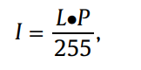

Where P->Structuring element Dot->Closing operation

The illumination is refined using guided filter

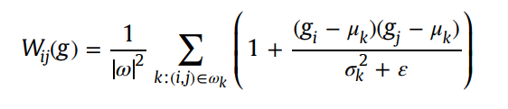

W->filter kernel and ω is the number of pixels in the window, μk and sk 2 are the mean and variance of g, ε is a regularization parameter.

1. **Inputs derivation**

In the proposed architecture, From the estimated lighting, three inputs are obtained. The original estimated illumination I is the first input, I1. This file contains information about the image's original structure, allowing us to avoid deformation.

The second input, I2, is intended to help clarify the image's dark areas by addressing the global brightness. To boost global luminance, many enhancing operators and functions, such as gamma correction and the sigmoid function, can be used. In this paper, we use the arc tangent transformation of I: to compute the second input.

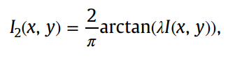

where λ ->degree of luminance λ should be changed adaptively thus following equation is used

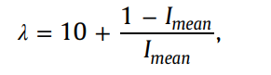

1. **Weights definition:**

Now we have to design weights so that three input image can be fused .pixel level weights are designed . The authors of the paper have experimented around the correct weight and they concluded mean should be around 0.5 and SD 0.25 and derived a expression

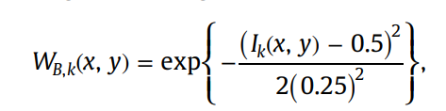

Second weight evaluated by combining estimated illumination with chromatic information and following equation is used to calculate



Then final weight is normalised to get the final weight.

1. **Multi Scale Fusion**

Getting adjusted illuminance is straight forward by using following equation

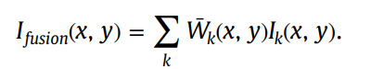

**Project Output:**

Input Image:

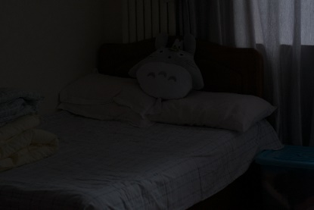 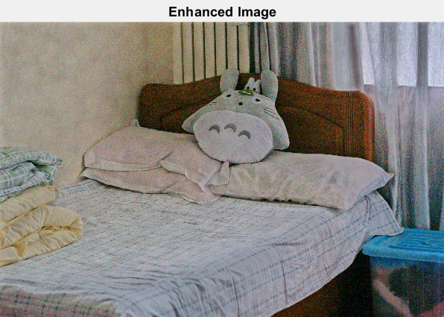

As we can see the model is performing excellently for the image with less noise .

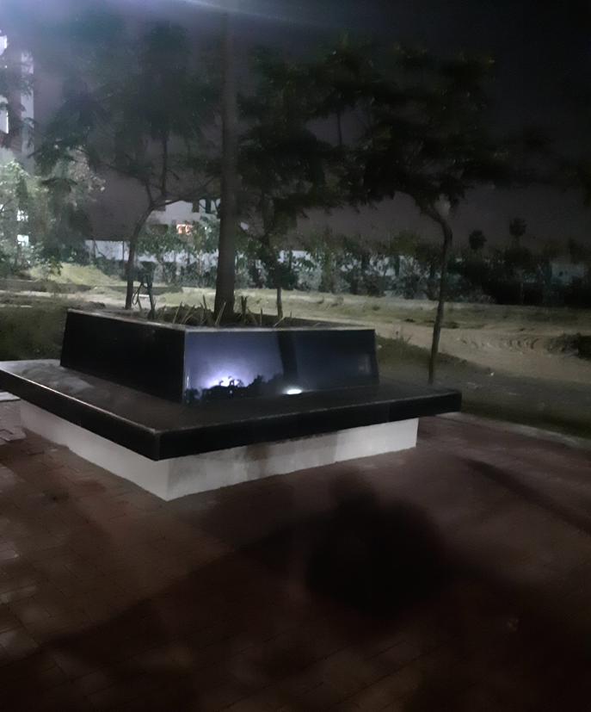 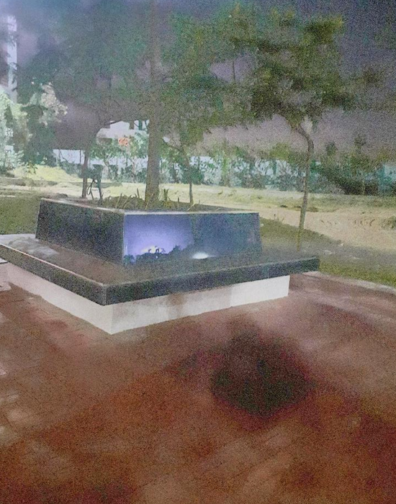

The model seems to struggle for image with very high noise

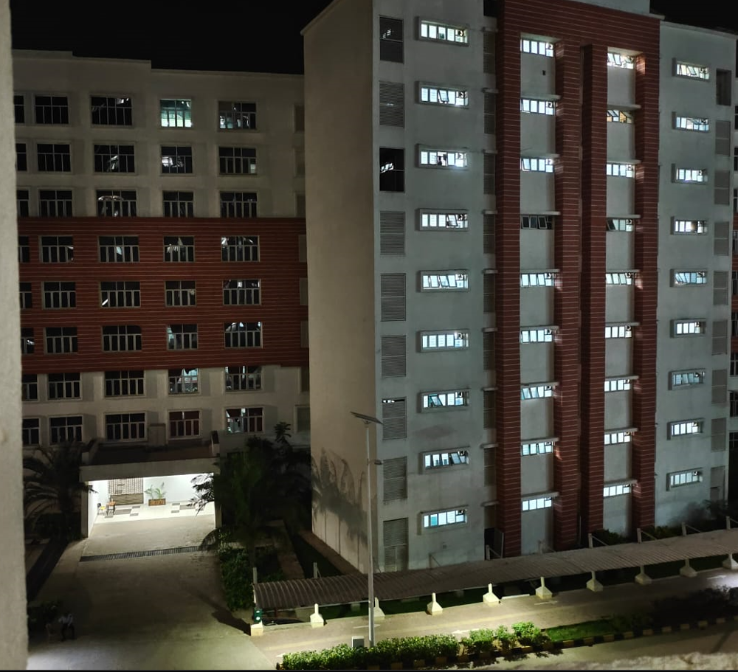 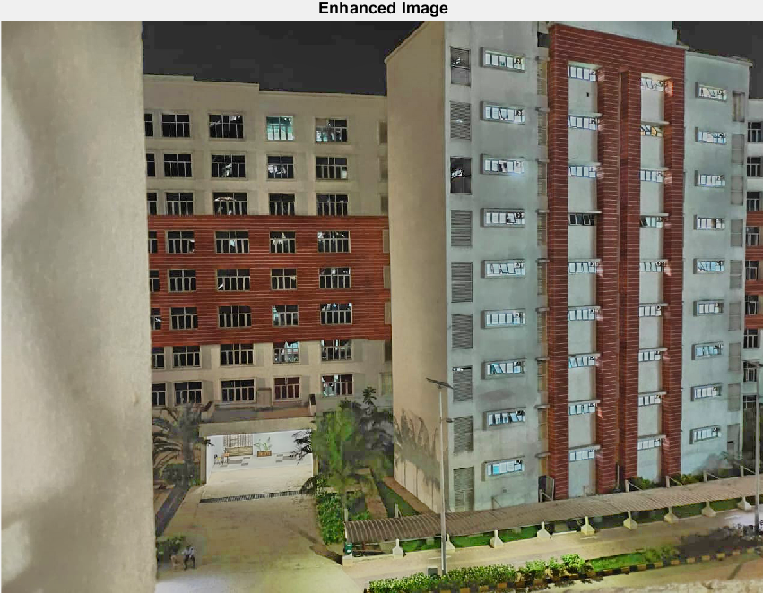

**Conclusion and Future work:**

The model is able to enhance low light image excellently considering it is computational inexpensiveness compared other neural network models

The model seems to be struggling for images having extreme noise. Additional noise removal algorithms can also be added to model to improve the overall model.

**References:**

[1] C. Lee, C. Lee, C.S. Kim, Contrast enhancement based on layered difference representation of 2d histograms, IEEE Trans. Image Process. 22 (12) (2013) 5372–5384.

[2] Z. Zhou, S. Li, B. Wang, Multi-scale weighted gradient-based fusion for multifocus images, Inf. Fusion 20 (2014) 60–72.

[3] T. Mertens, J. Kautz, F.V. Reeth, Exposure fusion, in: Proceedings of 15th Pacific Conference on Computer Graphics and Applications, 2007, pp. 382–390.

[4] Z.G. Li, J.H. Zheng, S. Rahardja, Detail-enhanced exposure fusion, IEEE Trans. Image Process. 21 (11) (2012) 4672–4676.

[5] R.C. Gonzalez, R.E. Woods, Digital Image Processing, Prentice-Hall, Englewood Cliffs, NJ, USA, 2007.

[6] E.D. Pisano, S. Zong, B.M. Hemminger, Contrast limited adaptive histogram image processing to improve the detection of simulated spiculations in dense mammograms, J. Digit. Imaging 11 (4) (1998) 193–200.

[7] Y.T. Kim, Contrast enhancement using brightness preserving bi-histogram equalization, IEEE Trans. Consum. Electron. 43 (1) (1997) 1–8.

[8] D. Coltuc, P. Bolon, J.M. Chassery, Exact histogram specification, IEEE Trans. Image Process. 15 (5) (2006) 1143–1152.

[9] T. Arici, S. Dikbas, Y. Altunbasak, A histogram modification framework and its application for image contrast enhancement, IEEE Trans. Image Process. 18 (9) (2009) 1921–1935.

[10] T. Celik, T. Tjahjadi, Contextual and variational contrast enhancement, IEEE Trans. Image Process. 20 (12) (2011) 3431–3441.